Quantitative Adjectives

🔹 What Are Quantitative Adjectives?
# Source: AI Source: Provided by: [Data Path: Persons Table -> ID Column: 1, Name_En Column: Motasem Essam] -> From: [Chatgpt (GPT-4-turbo)] on [7/27/2025]
Quantitative adjectives describe the quantity of something — they answer the question “how much?” or “how many?”
They are used with countable and uncountable nouns to express amount, number, or degree.

✅ Examples of Quantitative Adjectives
# Source: AI Source: Provided by: [Data Path: Persons Table -> ID Column: 1, Name_En Column: Motasem Essam] -> From: [Chatgpt (GPT-4-turbo)] on [7/27/2025]
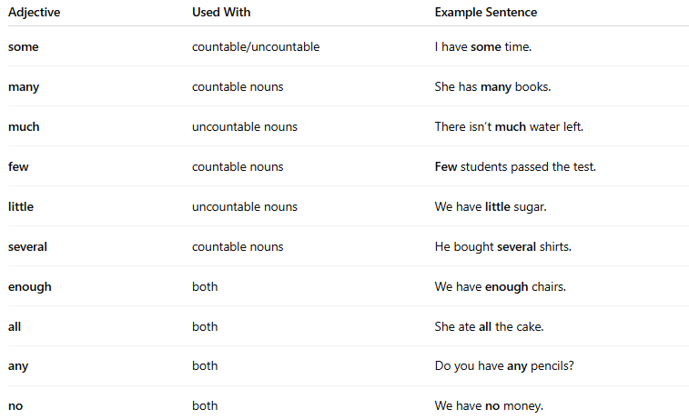
Adjective | Used With | Example Sentence
some | countable/uncountable | I have some time.
many | countable nouns | She has many books.
much | uncountable nouns | There isn’t much water left.
few | countable nouns | Few students passed the test.
little | uncountable nouns | We have little sugar.
several | countable nouns | He bought several shirts.
enough | both | We have enough chairs.
all | both | She ate all the cake.
any | both | Do you have any pencils?
no | both | We have no money.

📚 Examples in Sentences
# Source: AI Source: Provided by: [Data Path: Persons Table -> ID Column: 1, Name_En Column: Motasem Essam] -> From: [Chatgpt (GPT-4-turbo)] on [7/27/2025]
- He has three cats.
- I ate some rice.
- Much effort is needed to succeed.
- Many people joined the meeting.
- She has no time to waste.
- Enough food was cooked for everyone.

🧠 Tip:
# Source: AI Source: Provided by: [Data Path: Persons Table -> ID Column: 1, Name_En Column: Motasem Essam] -> From: [Chatgpt (GPT-4-turbo)] on [7/27/2025]
- Use “much, little” with uncountable nouns:
much water, little milk
- Use “many, few, several” with countable nouns:
many books, few apples, several pencils

